Bug 1 - The operation "addition" doesn't work correctly.

**Bug ID:** 1

**Bug Summary:** The operation ''addition'' doesn't work correctly. We get wrong answers.

**Environment/URL:** [**http://dev-qwallity.herokuapp.com/calculator**](http://dev-qwallity.herokuapp.com/calculator)

**Operation System:** Windows 8

**Version**: 1

**Browser:** Google Chrome

**Submit Date:** 10/11/2022

**Reporter:** Lilya Ghushchyan

**Steps to Reproduce:**

  1. Open the URL

2. Login

3. In the first field write 8

4. In the second field write 6

5. Select the operation addition

6. Click the button ''Calculate''

**Expected Result:** The result must be 14.0

**Actual Result:** The result is 16.0

**Screenshot/video:** Screenshot is attached

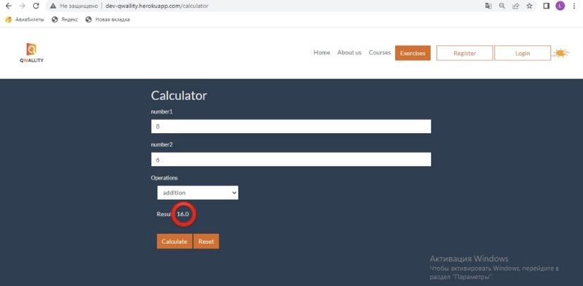

**Notes:** -

**References: -**

**Severity:** Critical

Bug 2 - The button "Reset" doesn't reset the 2nd field

**Bug ID:** 2

**Bug Summary:** The button ''Reset'' resets only the 1st field, it doesn't reset the 2nd field.

**Environment/URL:** [**http://dev-qwallity.herokuapp.com/calculator**](http://dev-qwallity.herokuapp.com/calculator)

**Operation System:** Windows 8

**Version**: 1

**Browser:** Google Chrome

**Submit Date:** 10/11/2022

**Reporter:** Lilya Ghushchyan

**Steps to Reproduce:**

1. Open the URL

2. Login

3. In the first field write 8

4. In the second field write 6

5. Click the button ''Reset''

**Expected Result:** Both fields must be replaced by 0.

**Actual Result:** The number 6 in the 2nd field isn't replaced by 0.

**Screenshot/video:** Screenshot is attached

**Notes:** -

**References: -**

**Severity:** Medium

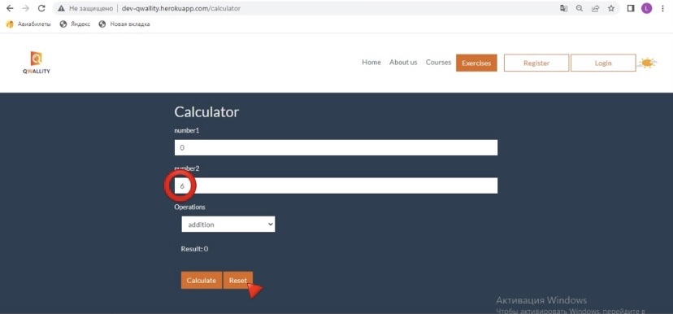

Bug 3 - Internal Server Error instead of the validation message

**Bug ID:** 3

**Bug Summary:** Internal Server Error instead of the getting the validation message when we don't write numbers in one of the fields.

**Environment/URL:** [**http://dev-qwallity.herokuapp.com/calculator**](http://dev-qwallity.herokuapp.com/calculator)

**Operation System:** Windows 8

**Version**: 2

**Browser:** Google Chrome

**Submit Date:** 10/11/2022

**Reporter:** Lilya Ghushchyan

**Steps to Reproduce:**

 1. Open the URL

2. Login

3. In the first field write 8

4. In the second field not to write any number

5. Select any of the operations

6. Click the button ''Calculate''

**Expected Result:** The validation message : "The 2nd field is required''

**Actual Result:** Internal Server Error

**Screenshot/video:** Screenshot is attached

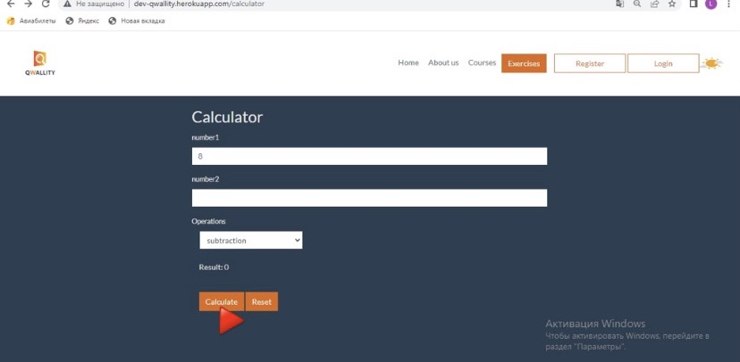

**Notes:** With all operations and with both fields we don't get the validation message.

**References: -**

**Severity:** Blocking